Weic Haaix Diuc Faaux Mienh Houz Jienv Bun Taux
Naamh Dong Yaac Ziou nyei Meiv Guoqv Mienh

Mouz norm 10 hnyangx, Meiv Guoqv (US) hungh jaa cuotv leiz zuqc maaih norm saauv dimv mangc mouz laanh mienh yiem njiec Meiv Guoqv heuc “faaux mienh houz” (census). Dieh norm faaux mienh houz oix jiez gorn yiem Fa’Hlaax 2020, weic bun-dunx $800 corng (billion) yiem zuangx zangc bun cuotv nyei zinh soux hnangv haaix nor haih nzie-weih gormx guoqv zangc nyei zuangx horngc zangc. Jiex daaih 2010 faaux mienh houz nyei buonc, gauh camv 650,000 Yaac Ziou Naamh Dong nyei Meiv Guoqv Mienh (SEAA), fai 23% nyei Naamh Dongh Yaac Ziou nyei Meiv Guoqv Mienh (SEAA), duqv lorz buatc maaih faaux bieqc mienh houz nyei soux mouc aiv haic, ei naaiv nor hiuv duqv “aqc funx maiv mengh.” Weic naaiv duqv biux mengh taux naaiv deix horngc zangc nyei mienh houz maiv duqv saauv bieqc, funx daaih ndortv nyei zinh nyaanh zungv haih bieqc mingh tengx taux ninh mbuo nyei horngc zangc jienv nyei gong kor, zorc jauv, tengx duqv heng-wangc nyei jauv gauh camv, bun tengx maaih yiem nyei biauv gauh camv, yaac maaih nyaanh gauh camv bieqc taux horqc dorngh.

YIEM 2010 NYEI FAAUX MIENH HOUZ

Ei Meiv Guoqv Faaux Mienh Houz 2010, Naamh Dong Yaac Ziou nyei Meiv Guoqv Mienh nyei Mienh Fingx

MEIH HIUV DUQV NYEI FAI?
Maaih nyungc baav benx aqc nyei jauv bun taux Naamh Dong Yaac Ziou nyei Meiv Guoqv Mienh nyei horngc zangc dinh faaux mienh houz daan se:
- Maiv bungx hnyouv hungh jaa — maaih Naamh Dong Yaac Ziou nyei Meiv Guoqv Mienh (SEAA) dongh yiem njiec Meiv Guoqv jien jaa duqv cuotv lingc dingc jienv zunc cuotv deic-bung nyei fai maiv maaih dorng leiz nyei sou-horngh. Ninh mbuo gaamv-nziex jien-jaa bangc faaux mienh houz zorqv ninh mbuo, maiv gunv 2020 faaux mienh houz liemh zungv maiv naaic taux benx Meiv Guoqv Baeqc Fingx nyei waac-naaic.
- Laaix maiv haih gorngv Anggitv waac — Leih maiv go yietc mbuonc Naamh Dong Yaac Ziou mienh yiem njiec Meiv Guoqv (SEAAs), duqv yiem ganh norm guoqv cuotv seix nyei mienh⁴ aqc hoqc gorngv Anggitv waac. Kamenx maaih 38.3%, Baeqc Miuh maaih 36.7%, Laau-zaa maaih 34.5%, caux Vietnaam maaih 38.6% nyei biauv zong mienh gorngv duqv Anggitv waac zoqc haic. beiv mangc yiem naaiv Meiv Guoqv nyei biauv zong mienh nor maaih 8.6%.
- Duqv nyaanh zoqc fai jomc ga’naanh - Naamh Dong Yaac Ziou nyei Meiv Guoqv Mienh (SEAA) nyei zuangx horngc zangc maaih jomc nyei bouc daauh hlang haic, 11% yiem Laau-zaa nyei hmuangv doic, 13% yiem Vietnaam nyei hmuangv doic, 14.9% yiem Kamenx nyei hmuangv doic, caux 16.3% yiem Baeqc Miuh nyei hmuangv doic, yiem gauh aiv jiex ndaangc jomc nyei bouc daauh.

WEIC HAAIX DIUC NYANGZ ZUQC NINH?
Weic zuqc Naamh Dong Yaac Ziou nyei Meiv Guoqv Mienh (SEAAs) nyangz taux bieqc buonc faaux mienh houz nyei jauv, yiem naaiv 2020 se gauh longc jienv jiex zuqc duqv mouz laanh yiem mbuo nyei horngc zangc haih duqv saauv nzengc. Zuqc saauv nzengc cingx haih beu duqv mbuo nyei horngc zangc:

- Zuqc duqv ninh mbuo nyei buonc zinh zoih. Naamh Dong Yaac Ziou nyei Meiv Guoqv Mienh (SEAA) nyei horngc zangc se sueih hungh jaa nzie-weih taux ninh mbuo hmuangv doic nyei gong kor hnangv. Mbuo haih ndortv zuqc ziex cin ndolaah (dollars) laaix ndortv maiv saauv zuqc nyei mouz laanh mienh, faaux mienh houz se kungx 10 hnyangx maaih yietc nzunc hnangv.

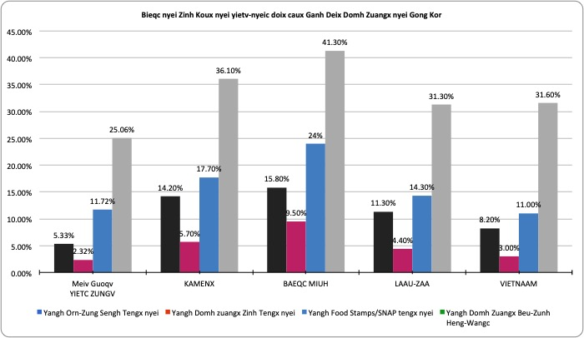

- Se buatc nqaengc nyei. Faaux mienh houz biux mengh bun zoux gong nyei mienh dingc hnyouv yiem haaix ndau zuqc njiec zinh soux buonv nyei dorngx.
  - Buonv-deic horqc dorngh gorn haih hiuv duqv zuqc gomv horqc dorngh yiem haaix fai maaih liuz nyei aengx zuqc capv jangv cuotv ndongc haaix,
  - Buonv-deic hungh jaa haih hiuv duqv liuc leiz mbenc qiemx zuqc hungh jaa tengx nyei biauv (housing) yiem nyei dorngx.
  - Ziux goux heng-wangc nyei ndie-sai haih hiuv duqv haaix nyungc ziux goux nzie-weih nyei heng-wangc yiem huing nzuonx ninh mbuo nyei baeqc fingx maaih qiemx zuqc nyei, caux
  - Jien-fouv haih hiuv duqv bouc soux baeng caux fongv taux leiz-zangc tengx bun horngc zangc mienh houz nyei maengc bun haih maaih gauh bieqc bouc.
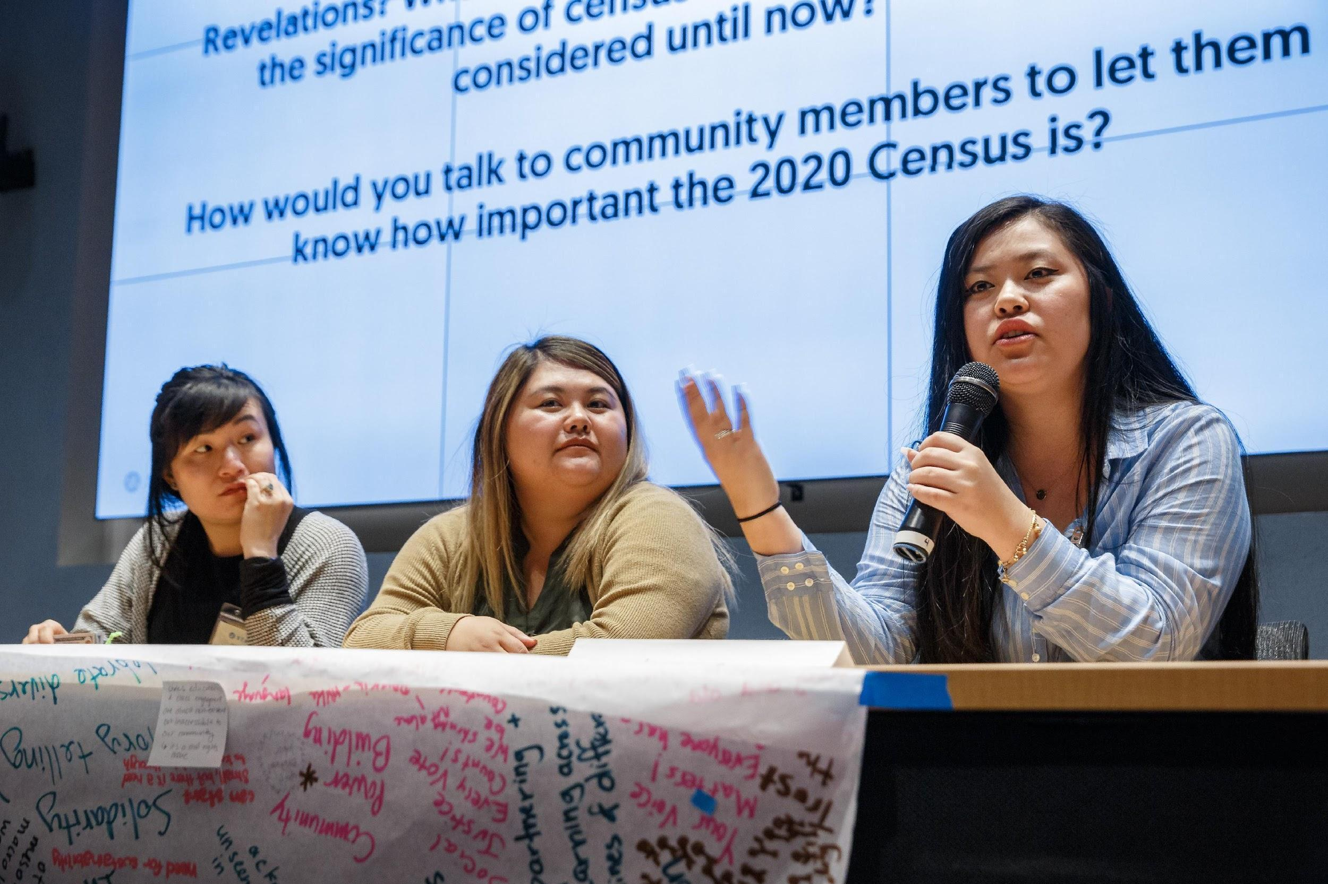

- Duqv ninh mbuo nyei baengh yuonh nyei ziuh zangc leiz-daauh dongh div nzuangx jien yiem Hungh Dorng nyei. Faaux mienh houz nyei bouc soux se zunv dingc oix bun hungh jaa haih duqv haiz meih mbuo nyei sing-qiex weic naaiv deix bouc soux:

  - Bun-dunx mbu’ziex norm jien-weic yiem Meiv Guoqv Div Zuangx Biauv mouz norm saengv duqv – ziuh zangc leiz-daauh nyei lingc haih duqv porv mengh weic meih nyei horngc zangc.
  - Maaih goiv yienc taux fouv zangc nyei ziuh zangc leiz-daauh caux yiem mouz nzangh nyei hungh jaa.
  - Beu taux sing nyei mienh, doix dekc caux maaih nqemh mienh fingx-piux zangc nyei sic daauh.
  - Zunv dingc baengh dangv nyei leiz-daauh zuqc mbenc maaih tengx faan waac nyei buonc bun taux sing nyei mienh.

Njiec Buoz Zoux
Saauv bieqc se tipv lingc bun! Faaux jienv mbuox benx 2020 nyei yietc laanh Faaux Houz Div Dorng caux tengx zunv dingc weic oix bun YIETC ZUNGV Naamh Dong Yaac Ziou nyei Meiv Guoqv Mienh bun haih duqv buatc yaac bun haih duqv haiz. Hoqc hiuv gauh camv bieqc mangc: bit.ly/SEARACCensusPledge

HNANGV HAAIX NOR HAIH HIUV DINGC MEIH SE DUQV FUNX BIEQC?
- Dinh meih nyei faaux mienh houz daan. Gorngv bieqc buonc faaux mienh houz nyei jauv mbuox mengh meih nyei doic caux hmuangv doic se jienv haic.
- Zimh mangc weic lorz hiuv gorn-baengx sou-horngh haaix zanc bun sou-daan cuotv, hnangv haaix nor dinh ninh, dongh haih tengx duqv nyei waac, gauh camv nyei.
- Zoux gong bun Faaux Mienh Houz nyei Zeqv-Weic Gorn benx yietc laanh tengx dimv mienh houz nyei mienh mingh taux mienh nyei biauv saauv ninh mbuo, se gorngv ninh mbuo maiv wuih faaux mienh houz daan. Lorz mangc maaih tong fienx tim jaa naaiv.

Meiv Guoqv Faaux Mienh Houz Zeqv-Weic, 2011-2015 Meiv Guoqv Mienh Horngc Zangc Dimv Mangc 5- Hnyangx nyei Soux Mouc, Mbaih Daaih B16004.
2 2010 nyei Setv mueiz Faaux Mienh Houx Maaih 20% nyei Fienx Daaux Nqaang Hnangv
3 https://www2.census.gov/programs-surveys/decennial/2020 / program-management/pmr-materials/10-19-2018/pmr-hard-to-count-2018-10-19.pdf?
Meiv Guoqv Mienh Horngc Zangc Zaah Dimv (ACS) – Meiv Guoqv Faaux Mienh Houz Gorn, 2010 1-year nyei buonc 4 Meiv Guoqv Horngc Zangc Zaah Dimv (ACS) – Meiv Guoqv Faaux Mienh Houz Gorn, 2011-2015 5-hnyangx myei buonc. Haih lorz duqv buatc yiem. https://factfinder.census.gov/faces/tableservices/jsf/pages/productview.xhtml?pid=ACS_15_SPT_DP02&prodType=table.
5 Meiv Guoqv Mienh Horngc Zangc Zaah Dimv (ACS) –Meiv Guoqv Faaux Mienh Houz Gorn, 2017 1-hnyangx nyei buonc

