Vim Li Cas Kev Suav Pejxeem Thiaj Tseemceeb Rau
Cov Laus Neeg Esxia Asmeslikas Hnub Tuaj Qab Teb

Txhua txhua 10 xyoo, tsoomfwv U.S. yuav tsum tau suav txhua tus neeg nyob rau teb chaws Asmeslikas los ntawm kev soj ntsuam hu tias “kev suav pejxeem.” Kev suav pejxeem zaum tom ntej no poob rau lub 3 hlintuj xyoo 2020, thiab nws yuav muaj feem txog ntawm kev faib tsoomfwv pob nyiaj $800 billion tuaj mus rau tej zejzog thoob teb chaw.
KOJ PUAS TAU PAUB?
Yuav luag 14% ntawm tag nrho cov neeg Asxia Asmeliskas qab Teb Hnub tuaj (SEAAs) nyob teb chaw Asmeliskas muaj hnub nyoog 55 xyoos los yog laus dua, nrog cov coob tshaj yog nyob rau cov zejzos Nyablaj yog 19.4% thiab qis tshaj yog nyob rau ntawm cov zejzos muaj neeg hmooob yog 7%.
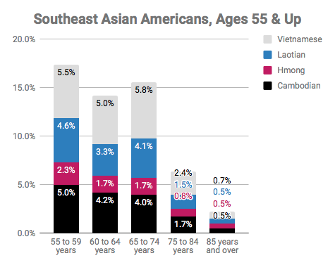

Thaum muab piv los SEAAs zejzos feem ntau muaj cov muaj hnub nyoog hluas dua cov neeg pejxeem US, SEAAs cov neeg laus tau ntsib tej teeb meem nyuab dua txog ntawm kev suav pejxeem, xws li:
- Paub lus Askiv tsis zoo
- Tsis muaj thev naus laus ntsi zoo
- Tau nyiaj qis los yog nyob txom nyem
- Kawm ntawv qis
- Muaj coob leej nyob ib tsev

Cov Lus nug Nquag Nug
VIM LI CAS COV LAUS THIAJ LI YUAV KHE TIAS LAWV YUAV TSUM TAU RAUG SUAV?
Kev suav pejxeem txiav txim seb pob nyiaj yuav tuaj mus rau kev pab cuam rau cov neeg txom nyem thiab cov laus li cas, xws li kev qhia ntawv rau cov laus, kev noj qab haus huv thiab kev kawm rau cov neeg muaj mob nrog cev, kev pab rau cov laus paub lus Askiv tsis zoo, kev pab nyiaj dawb xws li food stamps thiab ntawv kho mob, medical, Medicare, kev kho mob nkeeg, tsev kho mob, pab them nqi tsev li section 8 affordable housing, pab nrhiav hauj lwm rau cov laus, thiab ntau yam. Thaum koj teb cov lus nug kev suav pejxeem, koj pab kom muaj tseeb tias koj thiab koj tsev neeg muaj feem ntawm tsoomfwv pob nyiaj $800 billion tuaj pab rau kev pab cuam rau koj tus kheej tej kev noj qab nyob zoo.
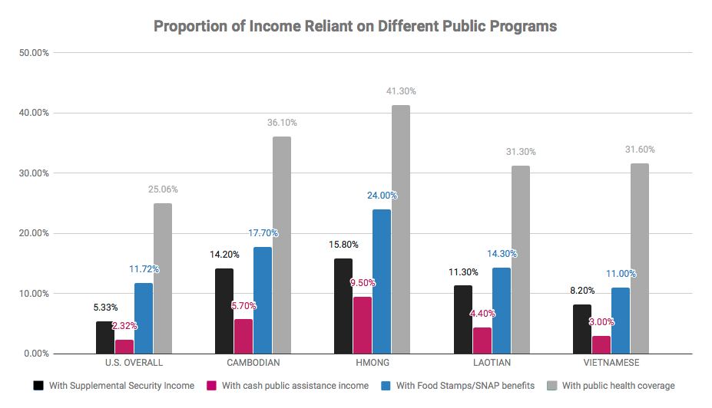
KUV YUAV KOOM TAU LI CAS YOG KUV TSIS MUAJ KHOOS PIJ TAWJ?
Koj muaj peev xwm koom tau kev suav pejxeem ntawm xov tooj los yog teb rau hauv ntawv. Tej thaum yuav tsis tag txhua yim neeg tau txais cov ntawv teb suav pejxeem no thawj zaug xa tawm, txhua yim neeg tsis tau teb cov lus nug txog kev suav pejxeem rov qab rau lub 4 hli ntuj tim 16-18 yeej yuav tau txais tsab ntawv nug no dua. Koj kuj muaj peev xwm nug tau ntawm tej chaws ua hauj lwm pab cuam zejzog, tsev qiv ntawv saib seb lawv puas muaj kev pab los yog muaj khoos phis tawj rau koj siv.

MUAJ KEV PAB LI CAS RAU COV NEEG TSIS PAUB NYEEM, SAU NTAUB NTAWV, LOS YOG HAIS TSIS TAU LUS ASKIV ZOO?
Tsab ntawv teb cov lus nug txog kev suav pejxeem koj teb koj nyob hauv Internet thiab teb hauv xov tooj muaj ua 12 hom lus tsis yog lus Askiv, nrog rau lus Nyablaj. Qhov chaw saib xyuas kev suav pejxeem muaj pab ua lus txhai meej, cov ntawv cim npe, thiab phau

ntawv qhia lus txog 59 hom lus tsis yog lus Askiv, nrog rau lus Hmoob, lus Khabmeem, lus Nlpog, thiab lus Nyablaj.

MUAJ KEV PAB DAB TSI RAU COV NEEG NYEEM TSIS TAU NTAWV?
Koj muaj peev xwm koom tau nyob rau hauv xov tooj.

MUAJ KEV PAB DAB TSI RAU COV MUAJ MOB NROG CEV THIAB YUAV MUAJ TEEB MEEM TEB RAU DAIM NTAWV NUG?
Koj muaj peev xwm koom tau nyob rau hauv xov tooj los yog online yog muaj thev naus lau ntsi txua tau. Koj muaj peev xwm thov kom ib tug neeg hauv tsev los yog txheeb ze pab koj sau teb cov lus nug.

LWM TUS NEEG PAB TEB COV LUG NUG TXOG KEV SUAV PEJXEEM RAU KUV PUAS TAU?
TSIS TAU. Thaum koj muaj peev xwm thov kom lwm tus pab taw kev txog daim ntawv teb rau koj thiab pab txhais rau koj, koj yuav tsis muaj peev xwm kom lwm tus pab teb cov luv nug ua koj tug rau koj.

Nqis Tes Uas
Kev raug suav yog ib lub zog loj! Tso npe ua ib tug sawv cev ntawm kev suav pejxeem xyoo 2020 thiab pab kom lawv hnov thiab pom txog TAG NRHO cov neeg Esxia Asmeslikas. Kawm ntau ntxiv: bit.ly/SEARACCensusPledge

KOJ YUAV UA LI CAS THIAJ PAUB MEEJ TIAS KOJ RAUG SUAV LAWM?
- Teb koj daim ntawv suav pejxeem. Qhia koj tej phooj ywg thiab tsev neeg txog kev suav pejxeem thiab piav qhia tias kev koom nws tseem ceeb heev.
- Qhia mus rau cov ntsiab lus qhia li muaj seb thaum twg daim ntawv mam tuaj, yuav teb li cas, muaj hom lus dab tsi pab txhawb txhais, thiab ntau ntau ntxiv.
- Ua hauj lwm rau qhov chaw suav pejxeem ua ib tug neeg ua hauj lwm suav neeg – ua tus neeg mus rau tib neeg tej vaj tse mus suav lawv yog lawv tsis teb cov ntawv suav pejxeem rov qab. Tshawb lus qhia ntau ntxiv ntawmno!

