Why Census is Critical for Southeast Asian Americans

Every 10 years, the US government is required to count every person living in the United States through a survey called “census”. The next census will start in March 2020, and it will determine how $800 billion in federal funding will be allocated to communities across the country. During the last census in 2010, more than 650,000 Southeast Asian Americans (SEAA), or 23% of the SEAA population, were found to live in areas of the country that had low census response rates or what are known as “hard-to-count tracts.” This means that these community members may have not been counted, resulting in loss of money that could have gone to their communities for important programs, like fixing roads, more health care, more affordable housing options, and more money to schools.

POPULATION IN HARD-TO-COUNT 2010 CENSUS TRACTS
By Southeast Asian American Ethnic Group, United States 2010
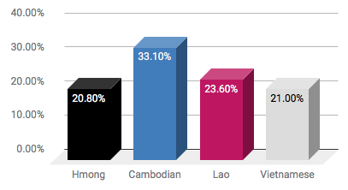

DID YOU KNOW?
Some factors that make it difficult for SEAA communities to fill out the census are:
- Distrust in the government — many SEAAs live in the United States with a pending deportation order or lack lawful status. They are afraid of being targeted by the Administration by participating in the census, even if the 2020 questionnaire will not have a citizenship question included.
- Limited English proficiency — About half of SEAAs in the United States are foreign born and struggle to learn English. Roughly 38.3% of Cambodian, 36.7%

of Hmong, 34.5% of Lao, and 48.6% of Vietnamese households that speak English less than “very well,” compared to 8.6% of total US households.
- Low income or poverty - SEAA communities experience poverty at very high rates, with 11% of Lao families, 13% of Vietnamese families, 14.9% of Cambodian families, and 16.3% of Hmong families still living below the poverty line.

WHY DOES IT MATTER?
Because SEAAs face these challenges to census participation, it is even more critical to ensure that everyone in our community gets counted in 2020. A complete count will ensure that our community:

- Gets their fair share of resources. SEAA communities depend on a number of government programs to support their families. We can lose thousands of dollars a year for each uncounted person since the census happens only once every 10 years.
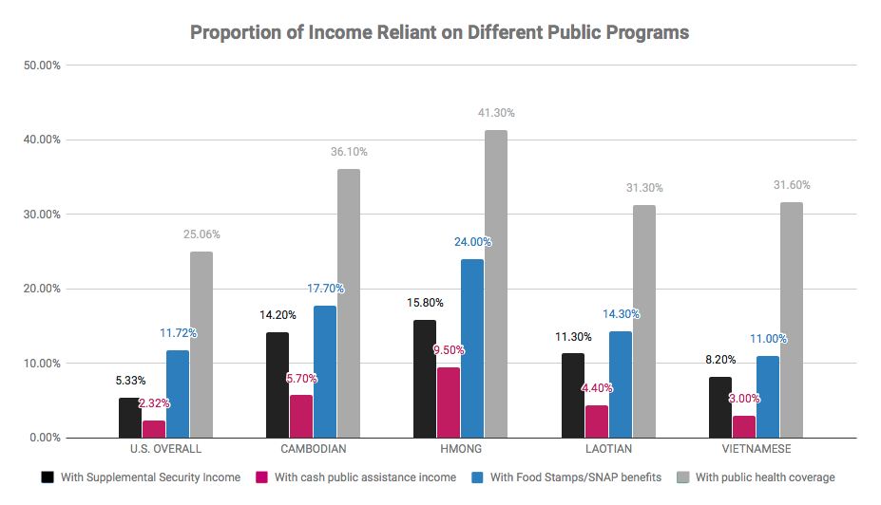

- Is visible. The census informs decision-makers on where to invest resources so that:
  - Local school districts will know where to build new schools or expand existing ones,
  - Local governments will know how to plan for housing needs,
  - Healthcare providers will know what type of care they need to prioritize for the populations around them, and
  - Advocates will have data to draft and push for policies to help improve the lives of community members.

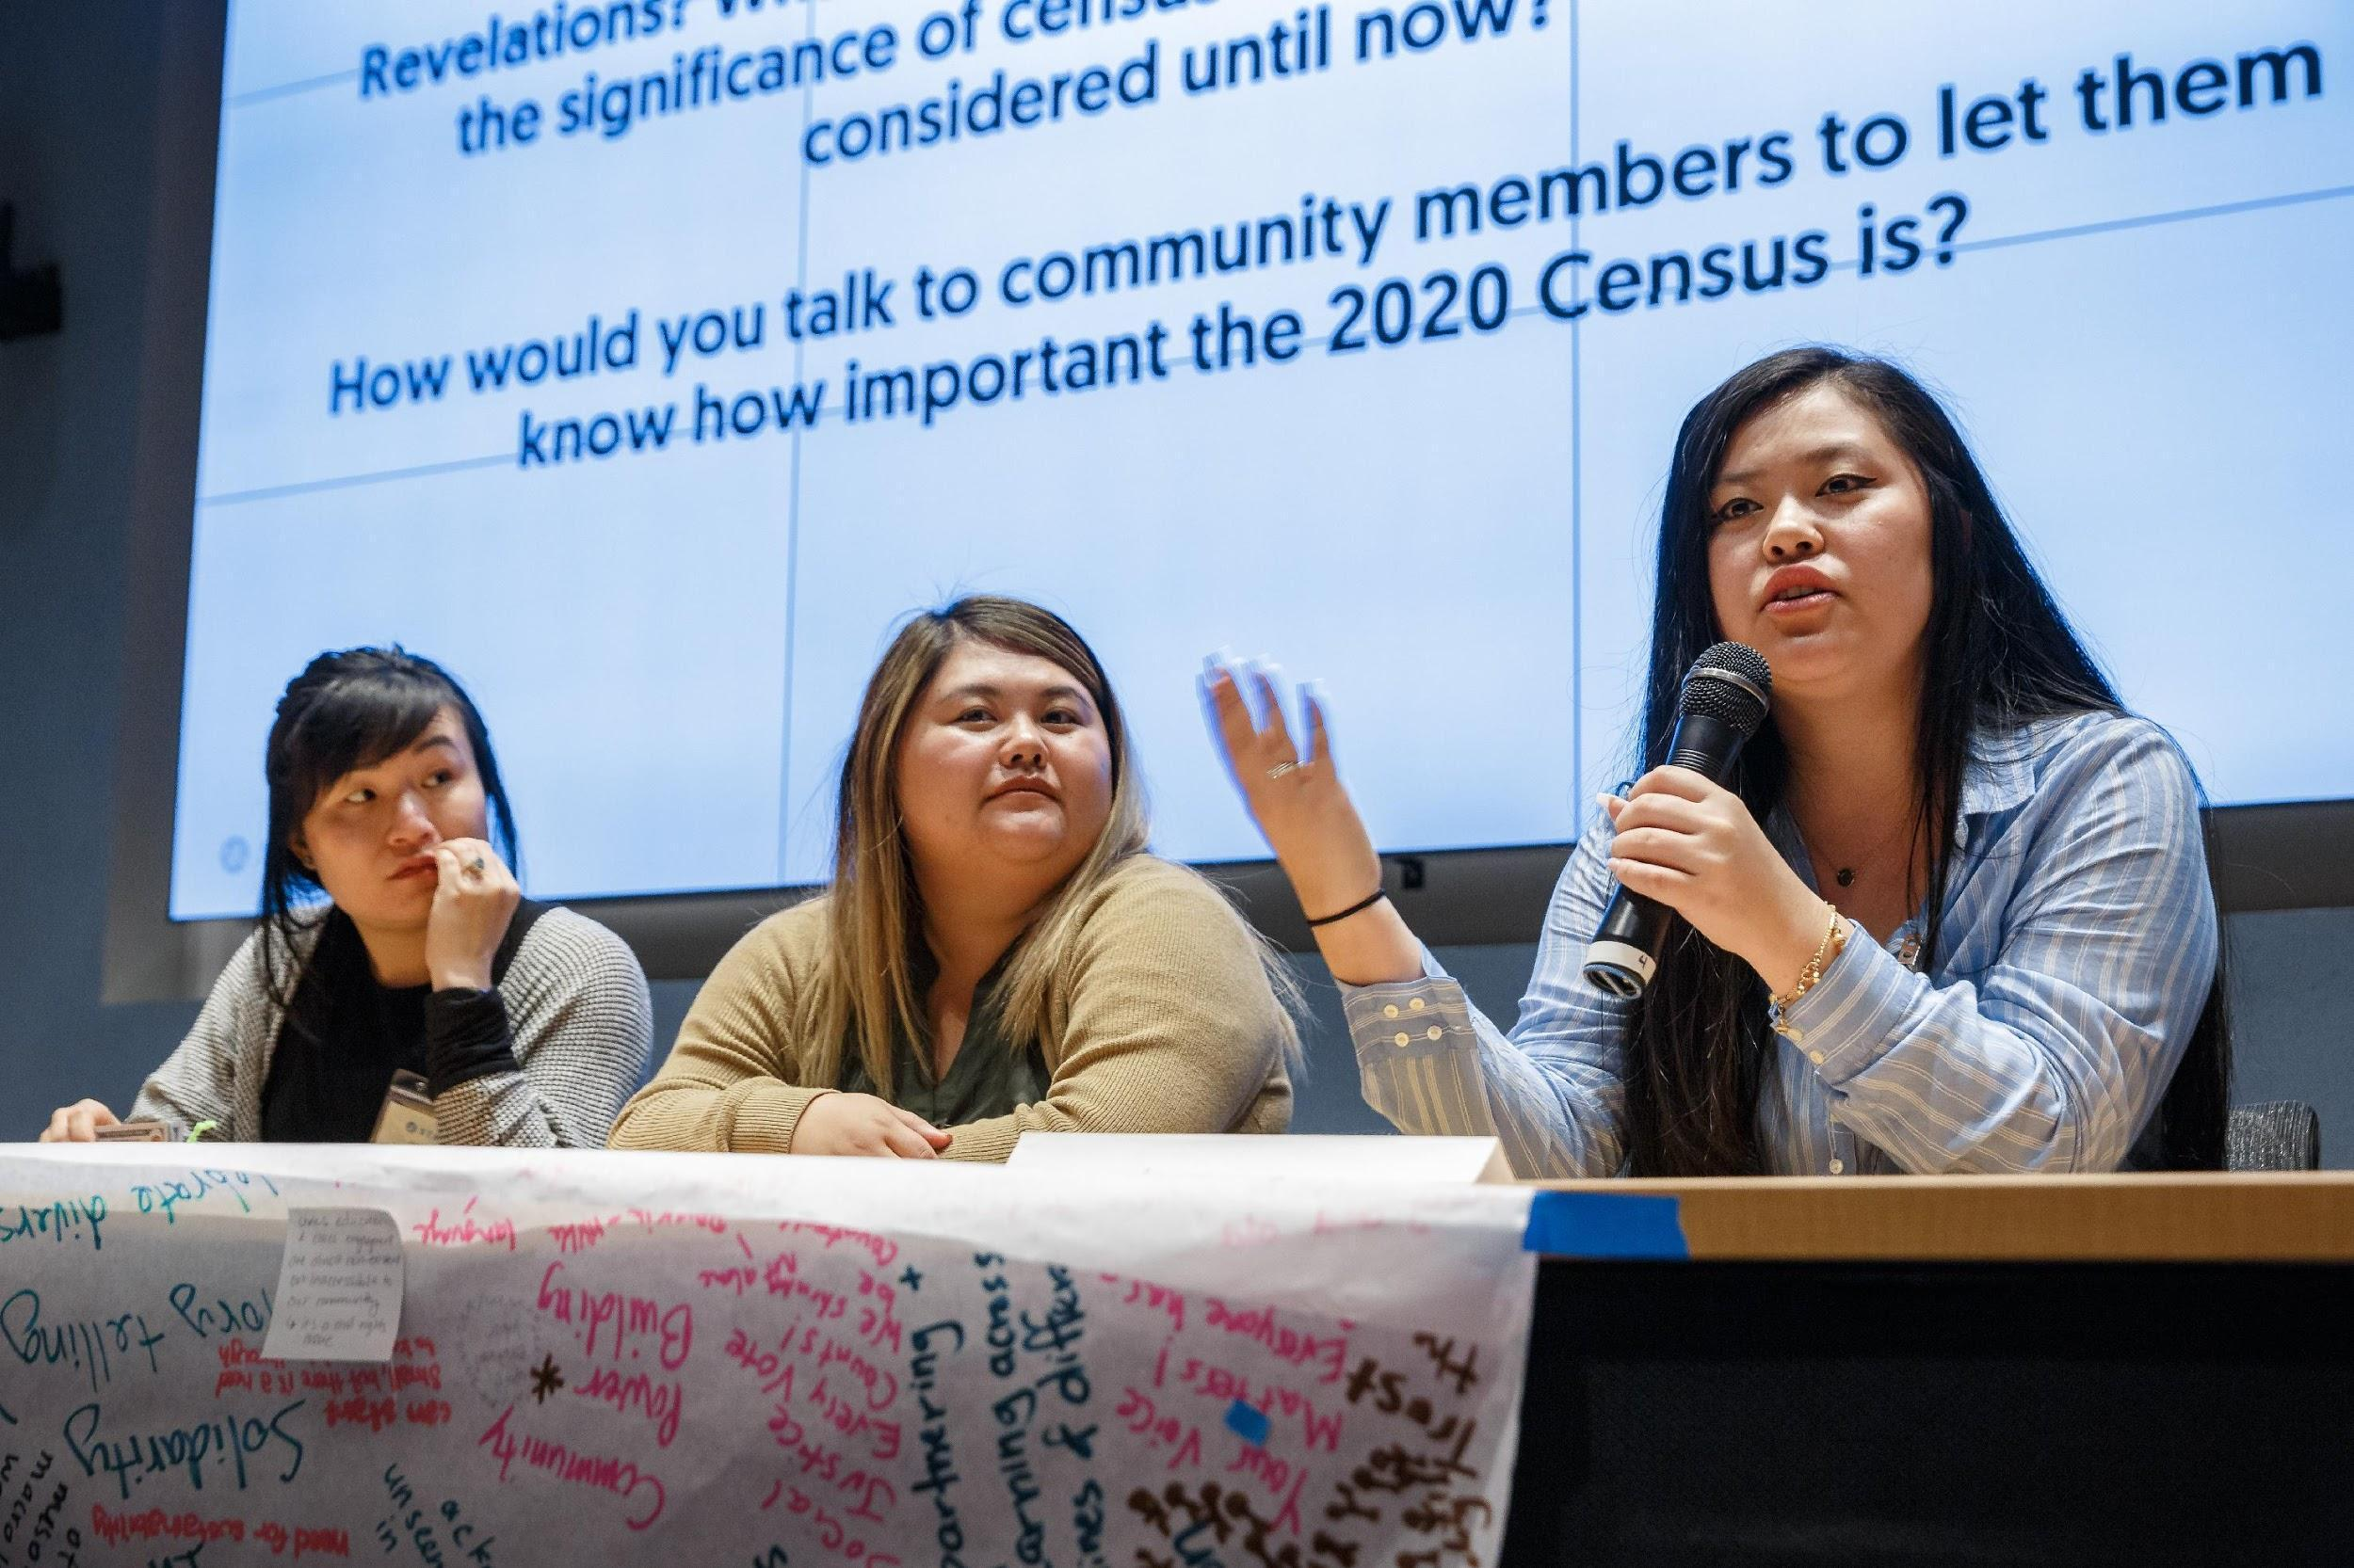
- Gets their fair share of political representation in Congress. Census data ensure that your voice is heard in government because the data:
  - Determine how many seats in the US House of Representatives each state gets — which translates to political power for your community.
  - Redraw political districts at all levels of government.
  - Protect voters against discrimination based on race.
  - Make sure jurisdictions provide language assistance to voters.

Take Action
There’s power to being counted! Sign up to be a 2020 Census Ambassador and help make sure ALL Southeast Asian Americans are seen and heard. Learn more: bit.ly/SEARACCensusPledge

WHAT CAN YOU DO TO MAKE SURE YOU’RE COUNTED?
- Fill out your census form. Tell your friends and family about the census and explain why it is important to participate.
- Reference the following resource(s) page to find out when the form comes out, how to fill it out, what language support is offered, and more.
- Work for the Census Bureau as an enumerator — the person who goes to peoples’ homes to count them if they do not respond to the census. Find additional information here.

U.S. Census Bureau, 2011-2015 American Community Survey 5-Year Estimates, Table B16004.
Bottom 20% of 2010 Census Mail Return Rates
https://www2.census.gov/programs-surveys/decennial/2020 / program-management/pmr-materials/10-19-2018/pmr-hard-to-count-2018-10-19.pdf?
American Community Survey (ACS) - U.S. Census Bureau, 2010 1-year estimates
American Community Survey (ACS) - U.S. Census Bureau, 2011-2015 5-Year Estimates. Retrieved from https://factfinder.census.gov/faces/tableservices/jsf/pages/productview.xhtml?pid=ACS_15_SPT_DP02&prodType=table.
American Community Survey (ACS) - U.S. Census Bureau, 2017 1-year estimates

