Why Census Matters for Southeast Asian American Youth and Children

Every 10 years, the US government is required to count every person living in the United States through a survey called “census.” The next census will start in March 2020, and it will determine how $800 billion in federal funding is allocated to communities across the country. Southeast Asian Americans (SEAA) families are more likely to experience one or more of the following growing up, making it more challenging to get counted in the census:
- Living in large households
- Growing up limited English proficient
- Having grandparents as primary caretakers

MAKING SURE THAT SOUTHEAST ASIAN AMERICAN CHILDREN GET COUNTED
Young children ages 0-4 had the highest net undercount rate and highest omissions rate of any age group in the 2010 Census. This resulted in 36 states losing out on $560 million each year for a number of programs, including Medicaid, Children’s Health Insurance Program, foster care, adoption assistance, and childcare.

DID YOU KNOW?
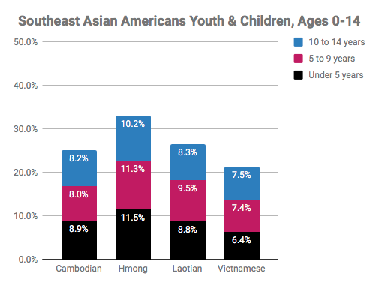
SEAAs are a relatively young population compared to the rest of the US, overall:
- Over 40% of Hmong Americans are under the age of 19; the highest proportion of youth compared to all racial groups and other SEAA ethnic groups. The proportion of Hmong American youth is double that of Whites.
- Hmong Americans have high proportions of young children (age 0-9) in comparison to all racial groups and other SEAA ethnic groups.
- Laotian, Cambodian, and Vietnamese Americans also have higher than average proportion of young children at 18.3%, 16.9%, and 13.8%

respectively compared to 12.8% for the total US population.
- Laotian, Cambodian, Hmong, and Vietnamese Americans have higher than average proportions of grandparents living with their grandchild(ren) at 9.3%, 9.1%, 8.8%, and 6.2%, respectively, compared to 3.6% for the total US population— a factor that could potentially make it more difficult to count children.

Frequently Asked Question(s)
WHY SHOULD WE CARE ABOUT MAKING SURE THAT OUR CHILDREN GET COUNTED?
The census count determines how many resources will go to critical programs and services for our children, including schools and education programs (Head Start, Title I funding to improve academic support for low-achieving children), public benefits (Women, Infants, & Children food grants, SNAP or food stamps, and healthcare (Medicaid, CHIP), among many others. Participating in the census helps to ensure that our children get the programs and services they need to be healthy, thriving, and successful in the future! Make sure that you count everyone living in your household on Census Day (April 1, 2020), including children, grandchildren, nieces, nephews, and children of friends.
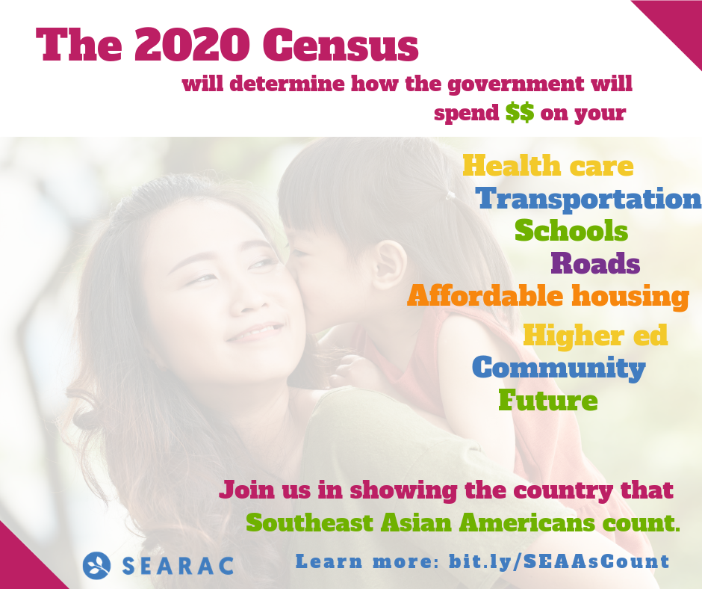

HOW SHOULD WE COUNT CHILDREN WHOSE PARENTS ARE DIVORCED AND SHARE JOINT CUSTODY IF THEY HAVE MORE THAN ONE HOME?
Children should be counted in the household they are living on Census Day (April 1, 2020).

HOW DO I COUNT MY CHILD WHO IS CURRENTLY LIVING AWAY FROM HOME AT COLLEGE?
College students should be counted in the location they are staying on Census Day (April 1, 2020).

HOW SHOULD PREGNANT WOMEN PLAN TO COUNT THEIR BABY?
You should count the number of people in your household on Census Day (April 1, 2020). If the baby has not been born yet, they should not be counted.

Take Action
There’s power to being counted! Sign up to be a 2020 Census Ambassador and help make sure ALL Southeast Asian Americans are seen and heard. Learn more: bit.ly/SEARACCensusPledge

WHAT CAN YOU DO TO MAKE SURE YOU’RE COUNTED?
- Fill out your census form. Tell your friends and family about the census and explain why it is important to participate.
- Reference the following resource(s) page to find out when the form comes out, how to fill it out, what language support is offered, and more.
- Work for the Census Bureau as an enumerator — the person who goes to peoples’ homes to count them if they do not respond to the census. Find additional information here!

“Make Sure Every Kid Count in the 2020 Census”: https://www.newamerica.org/education-policy/edcentral/make-sure-every-kid-counts-2020-census/
U.S. Census Bureau, 2010 SF2, Table DP-1.
U.S. Census Bureau, 2010 SF2, Table DP-1.
American Community Survey, 2015 5-year estimates
American Community Survey, 2015 5-year estimates
American Community Survey, 2015 5-year estimates

