Why Census Matters for
Southeast Asian American Young Adults

Every 10 years, the US government is required to count every person living in the United States through a survey called “census.” The next census will start in March 2020, and it will determine how $1.504 trillion in federal funding will be allocated to communities across the country. A sizable proportion of the Southeast Asian American (SEAA) community are young people:
- The median age of SEAAs is below that of the average US population of 37.2. Of the SEA ethnic groups, Hmong Americans have the lowest median age of 20.5.
- Hmong Americans have high proportions of college-aged young adults (age 18-24) in comparison to all racial groups and other Southeast Asian American ethnic groups.
- Laotian and Cambodian Americans also have higher than average proportion of college-aged youth at 12% and 14%, respectively.
DID YOU KNOW?
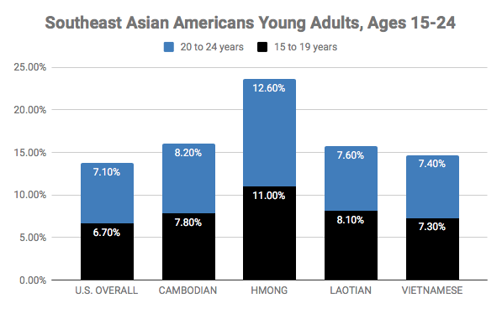
Over 40% of Hmong Americans are under the age of 18; the highest proportion of youth compared to all racial groups and other SEAA ethnic groups. The proportion of Hmong American youth is double that of Whites.

Frequently Asked Question(s)
WHY SHOULD YOUNG PEOPLE CARE ABOUT THE CENSUS?
The census count determines how resources are allocated to schools, healthcare, and other essential programs — the more people counted in your community, the more funding your community receives. When you respond to the census, you help make sure that your family and community get their fair share of funding, services, and political representation! Census data are used in all kinds of ways, including:
Education: Participating in the census means more money for critical education programs that directly benefit you, including funding for low-income students, bilingual language programs, and career and technical education.
Fair Share of Resources: Census data determine how federal funding is allocated for programs and services, but businesses also use census data to decide where to invest and create jobs. Filling out the census ensures you, your family, and your community a fair shot at those resources.

Visibility: Completing the census provides valuable information to inform decision-makers where to invest resources and helps them understand our community, our needs, and our valuable contributions to this country. Advocates will also have the data to draft and push for policies to help improve the lives of your community.

Political Representation: Census results determine political representation, including how many seats in Congress states receive and how districts are drawn for state and local government. This translates into political power for your community!

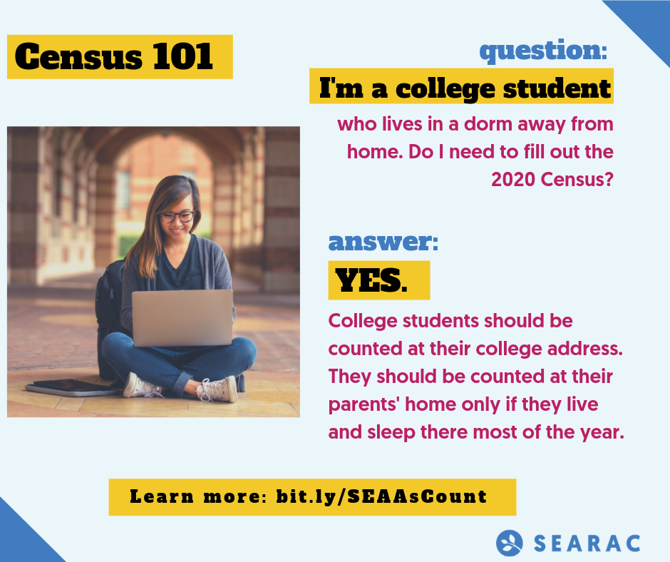
AT WHICH ADDRESS SHOULD I BE COUNTED IF I’M AT COLLEGE AND DON’T LIVE AT HOME?
According to the census rules, you should fill out the address at the residence where you reside most of the time or wherever you are on Census Day (April 1, 2020). For example, if you are living on campus in a dorm on Census Day, that is where you should be counted.
DO I COUNT MY ROOMMATE(S) IN THE CENSUS QUESTIONNAIRE?
When you fill out the census, you include everyone who is living there on Census Day, including roommates!

DOES THE CENSUS QUESTIONNAIRE OFFER OTHER GENDER OPTIONS?
The census is still gender binary. Historically, people have skipped this particular question and have still been counted.
HOW DO I PARTICIPATE IF I AM STUDYING ABROAD OR TRAVELLING FOR THE NEXT SIX MONTHS?
You can participate in the census online! From mid-March 2020 through early May 2020, the Census Bureau will mail you census questionnaires and information (including your unique ID) about where to fill out the form online.
WHAT DO I LIST AS MY CURRENT ADDRESS IF I AM TRAVELLING FOR THE NEXT SIX MONTHS?
You should fill out the address at the residence where you live and sleep most of the time, even if you will not be back there for several months.
WHAT IS MY UNIQUE IDENTIFICATION CODE FOR RESPONDING ONLINE?
If you are unsure of your unique identification code for responding online, you can still submit via the Census Bureau’s website by providing your address.
WHAT SUPPORT IS AVAILABLE TO THOSE WHO DON’T READ, WRITE, OR SPEAK ENGLISH VERY WELL?
The Internet self-response form and census questionnaire assistance phone line is available in 12 non-English languages, including Vietnamese. The Census Bureau is also providing language glossaries, language identification cards, and language guides in 59 non-English languages, including Hmong, Khmer, Laotian, and Vietnamese.

Take Action
There’s power to being counted! Sign up to be a 2020 Census Ambassador and help make sure ALL Southeast Asian Americans are seen and heard. Learn more: 2020census.paperform.co

WHAT CAN YOU DO TO MAKE SURE YOU’RE COUNTED?
- Fill out your census form. Tell your friends and family about the census and explain why it is important to participate.
- Reference the following resource(s) page to find out when the form comes out, how to fill it out, what language support is offered, and more.

- Work for the Census Bureau as an enumerator - the person who goes to peoples’ homes to count them if they do not respond to the census. Find additional information here!
Thank you to our partners Boat People SOS-Houston, Cambodian Families of Santa Ana, Freedom Inc., the Fresno Center, and Iu-Mien Community Services for your generous support with translations. The Word versions of these factsheets are open for download and editing to fit the needs of different communities. For additional questions, contact searac@searac.org.

U.S. Census Bureau, 2010 SF2, Table DP-1.
U.S. Census Bureau, 2010 Census SF2, Table PCT3.
U.S. Census Bureau, 2010 SF2, Table DP-1.

