What Immigrants Need to Know About Census

The US Constitution explicitly states that the census is intended to count every person living in the United States, both citizens and non-citizens alike. It will ask basic questions about each person who lives in your household, like age, name, race, and ethnicity, but it will not ask about your immigration status or whether you are a US citizen. Despite this, many segments of the Southeast Asian community may still be afraid to participate in the 2020 Census if they are refugees or immigrants who are undocumented, have a deportation order, or are a non-citizen.

MAKING SURE THAT ALL SOUTHEAST ASIAN IMMIGRANTS GET COUNTED
Remember that your census responses are totally confidential and protected by extremely strong laws:

- The Census Bureau is not allowed to share individual responses with anyone, including immigration enforcement and other government agencies.

- The Census Bureau cannot use your census response for any purpose other than statistical analysis.

- A violation of these laws can result in up to $250,000 in penalties or 5 years in prison.

Frequently Asked Question(s)
WHAT IS REALLY AT STAKE FOR THE 2020 CENSUS?
$800 billion in federal funding. The census count determines how many resources will go to schools, healthcare, and other essential programs — the more people counted in your community, the more funding your community receives. When you respond to the census, you help make sure that your family and community get their fair share of funding, services, and political representation!
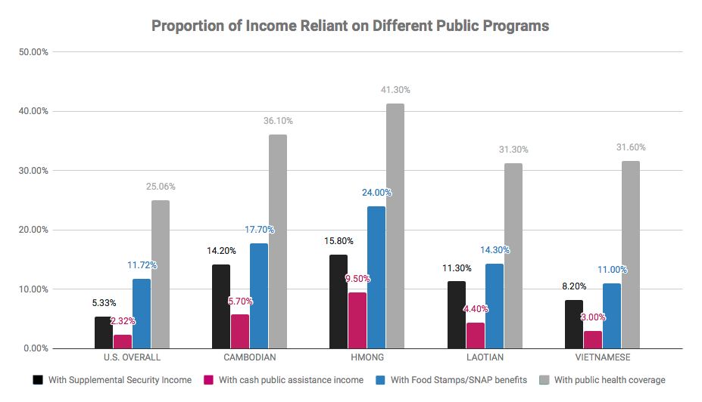

WHAT HAPPENS IF I SKIP A QUESTION?
Your form will still be counted if you skip a question or two, as long as you provide your name and address. If you skip questions or don’t answer the census at all, the Census Bureau might follow up to ask for the missing information, either by phone or by sending a Census Bureau employee to your home. The fewer questions that you skip, the less likely it is that the Census Bureau will follow up.

WILL THERE BE A CITIZENSHIP QUESTION?
NO. The Supreme Court recently decided AGAINST the addition of citizenship question on the 2020 Census because it would be unconstitutional. The Census Bureau has already begun printing the 2020 questionnaire without it.

EVEN WITHOUT THE CITIZENSHIP QUESTIONS, I’M STILL AFRAID OF BEING TARGETED SINCE I’M AN IMMIGRANT. WHAT DO I DO?
Southeast Asian immigrants carry legitimate concerns given the Trump Administration’s recent record of escalated enforcement. In particular, immigrants who are undocumented, have a deportation order, or are a non-citizen may particularly be afraid of being targeted. If you fall under any of these categories, remember that the exclusion of a citizenship question coupled with strong confidentiality protections, make it very difficult for the government to target non-citizens. The law requires everyone, including all immigrants regardless of status, to respond to the census completely, and to answer all the questions truthfully. But more importantly, census participation ensures that all SEAAs are able to access the full rights and privileges they deserve.

Take Action
There’s power to being counted! Sign up to be a 2020 Census Ambassador and help make sure ALL Southeast Asian Americans are seen and heard. Learn more: bit.ly/SEARACCensusPledge

WHAT CAN YOU DO TO MAKE SURE YOU’RE COUNTED?
- Fill out your census form. Tell your friends and family about the census and explain why it is important to participate.
- Reference the following resource(s) page to find out when the form comes out, how to fill it out, what language support is offered, and more.
- Work for the Census Bureau as an enumerator - the person who goes to peoples’ homes to count them if they do not respond to the census. Find additional information here!

